Refinery Profit Maximization

EBGN-645
FALL 2025

Final Project
Abdulrahman Alturki
12/01/2025

Table of Contents:
Executive Summary 3
Background & Research Questions: 4
Motivation and Significance: 5
Model Structure 6
Assumptions Formulation Difficulties, , and Data Resources 8
Results Summary & Interpretation: 9
Vision for Future Advancement/Expansion: 12
Conclusion: 13
Appendix: 14

Executive Summary

Background & Research Questions:
The energy sector is a major part of global economic development, supplying fuels for operating industries, facilitating transportation, and meeting necessary life needs. In that sector, refineries play a major role as they convert crude into petroleum products such as gasoline and middle distillate (MD), in which their operations are sensitive to crude price fluctuations, crude availability, operational reliability, environmental regulations, and processing capacity limitation. Providing these challenges, optimization models have been critical tools for planning production, scheduling maintenance activities, controlling costs, running sensitivity cases, and enhancing operational and logistical decisions. The model shows how refinery is flexible to partially adjust its product yields (quota allocated for each product) by adjusting the operating philosophy depending on the capability of downstream units of Crude Distillation Unit (CDU).
Thus, the objective of this project is to investigate how an integrated LP, NLP, and MCP modeling structure can assess refinery performance, optimize product allocation, and measure market impacts perspective (supply/demand shifts) due to applying tax policies and subsidies. The aim of this study is to show how refineries generate profit and adjust production figures in response to market challenges and across several scenarios to show how production levels vary across LP, NLP, and MCP.
The objective of this comprehensive model is to provide insights for optimizing refinery operations and how to handle operational challenges, market dynamics, and policy effects on refined products allocation. The following figure simplifies the idea of refinery operations:
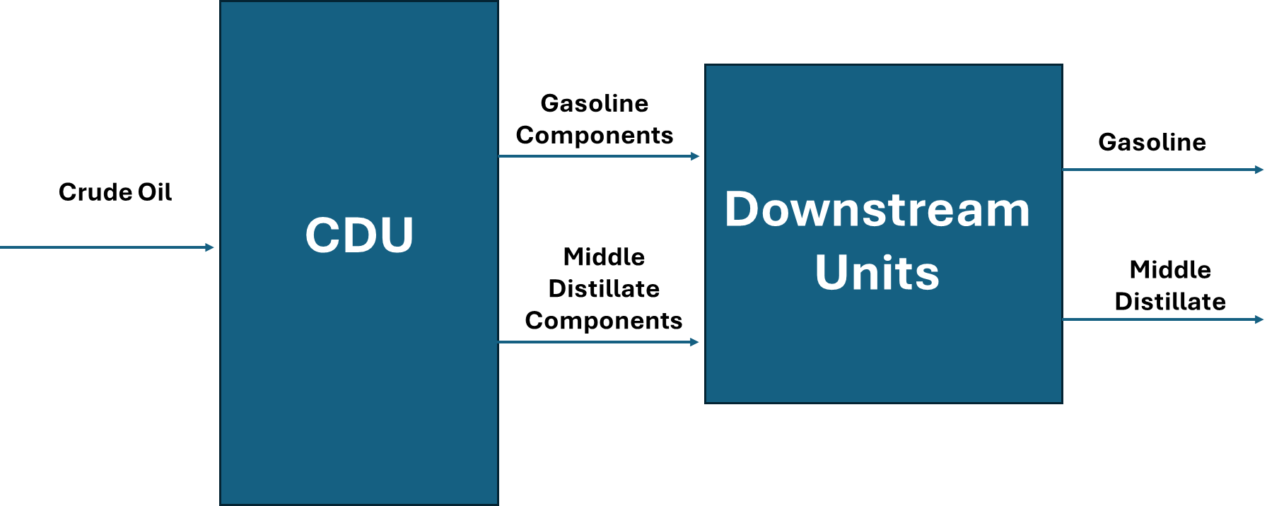

Motivation and Significance:
The motivation for this project comes from the increasing complexity of global markets and the needs for modeling programs that centralize technical refinery decisions with real market responses.
For refineries, the model helps identify the best combination of petroleum products and pricing strategies that lead to profitability. As for policy introduction, it provides an idea of how taxes or other policies affect market prices and production levels. The combination of real data and economic modeling aims to support efficient refinery management and establish a balance between economic growth and environmental goals.
Beyond its technical importance, the project has an objective to highlight the understanding of how optimization and market equilibrium models can work together to explain real-world energy dynamics. It highlights the significance of integrating operational and policy changes to achieve sustainable, efficient, and precise decisions in the refining business. In the next section, the report introduces the structure of LP, NLP, and MCP models in detail, and how the code is modeled and applied in this framework.
One of the most interesting parts in the refinery optimization model is the combination of economic insight, technical expertise, and engineering knowledge, ensuring efficient balance between economic objectives and refinery operation capability

Model Structure
The model consists of LP, NLP, and MCP as illustrated below:
Sets/ Indices:
- Products i € {G,MD}; G=Gasoline, MD=Middle Distillates (Diesel & Jet Fuel);
- Suppliers s € {s1,s2}
Parameters:
- Refinery and Market Constants:
  - X_rate ≥ 0: Total refinery throughput (bbl/day)
  - C₀: Fixed cost ($)
  - W: Crude oil price ($/bbl)

- Demand and Supply Averages
  - P_{avg,i}: Average market price of product i
  - Q_{avg,i}: Average market quantity of product i
  - (E_{i})^{D}: Price elasticity of demand
  - (E_{i})^{S}: Price elasticity of supply

- Isoelastic MCP Values
- $\overline{P}d$ > 0: Reference demand price
- $\overline{q}d$ > 0: Reference demand quantity
- (E_{i})^{D} > 0: Demand elasticity
- $τ^{D}$ > 0: Demand-side tax multiplier
- $\overline{P}s$ > 0: Reference supply price
- $\overline{q}s$ > 0: Reference supply quantity
- (E_{i})^{s} > 0: Supply elasticity
- $τ^{S}$> 0 Supply-side tax multiplier
Variables:
LP/NLP:
- Qi > 0: Total production of each product
- K > 0: Total refinery production
- $π$: Profit for LP model (objective value in $)
- $TS$: Total surplus (NLP objective value)
MCP:
- P € $\left[p_{\left\{min\right\}}, p_{\left\{max\right\}}\right]$
- q_{s} € $\left[q_{\left\{min\right\}}, q_{\left\{max\right\}}\right]$
- Q^{tot}: Total quantity (bbls)
Equations & Constraints:
- LP Model:
max$π$ = $\sum{(Pavg,i}$ * Qi) – WK - C₀
K = $\sum{Qi}$
K < X_rate
0.3* X_rate ≤ Q_{i} ≤ 0.7 * X_rate
- NLP Model:

Demand function: P(d) = a – b*Q
$Q=\frac{a-P}{b}$
Supply function: P(s) = c + d*Q
$$Q=\frac{P-c}{d}$$

At Equilibrium: a–b* Q = c +dQ , $Q=\frac{a-c}{b+d}$

We can identify slopes from elasticity as shown below
Demand Slope: $b= |\frac{1}{∈_{d}}|*\frac{P_{avg}}{Q_{avg}} , Note: ∈_{d} is usually negative$

Demand Intercept: a= P(d) + b*Q

Supply Slope: $d= \frac{1}{∈_{s}}*\frac{P_{avg}}{Q_{avg}}, Note: ∈_{s} is usually positive$

Supply Intercept: c = P(s) - d*Q

Then, we move to CS & PS calculations according to the following sketch:
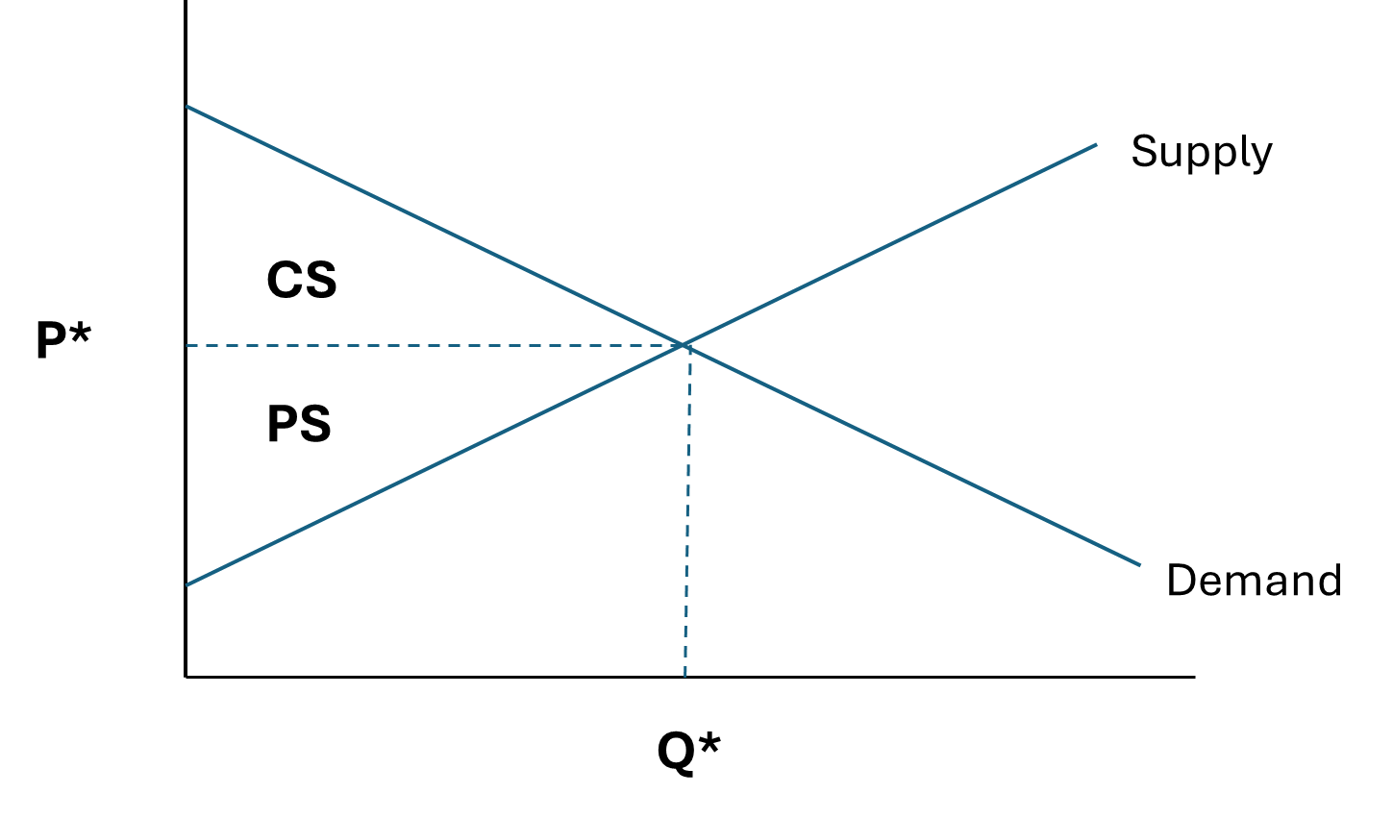

$$CS=\int_{0}^{Q}{\left(Pd-P^{*}\right)dq=}\int_{0}^{Q}{\left(a-bq-P^{*}\right) dq=aQ^{*}-\frac{b{{(Q}^{*})}^{2}}{2}-P^{*}Q^{*}}$$
$$PS=\int_{0}^{Q}{\left(P^{*}-P(s)\right)dq=}\int_{0}^{Q}{\left(P^{*}-\left(c+dq\right)\right)dq=P^{*}Q^{*}-cQ^{*}-\frac{d{{(Q}^{*})}^{2}}{2} }$$
$$TS=aQ^{*}-\frac{b({Q^{*})}^{2}}{2}- cQ^{*}--\frac{d({Q^{*})}^{2}}{2}$$
$$TS=\left(a-c\right)Q^{*}-\frac{\left(b+d\right)({Q^{*})}^{2}}{2}$$

We calculate CS to quantify buyer’s benefit, and PS to quantify seller’s benefit.

- MCP Model for market equilibrium with isoelastic demand & supply with taxes

0 ≤ $∑qs-$ $\overline{P}d$ ($\frac{τ^{D} p}{\overline{P(}d)})$ ^{E}_{D}
$τ^{S}$ $\overline{P}s$ (S) ($\frac{qs}{\overline{q}s (S)})$ ^{(S) E}_{S} ≥ P

Q^{tot} - $∑qs=0$

Assumptions Formulation Difficulties, , and Data Resources
- Major Assumptions:
- Single period model, in which time change effect is not considered here.
- Demand is huge and the optimization is done by single refinery, which means the refinery runs at max capacity as long refined product price is higher than crude oil price.
- Constant elasticity of supply and demand for both gasoline and MD.
- Taxes are modeled as percentage multipliers on prices for supply.
- Fixed capacity of refinery throughput at 140,000 bbl/day.

- Formulation Difficulties:
Developing the refinery optimization model consists of integrating three components namely, LP model for refinery profit, NLP model for total market welfare, and MCP model for price-quantity equilibrium.
Each component has its own specific mathematical structure. The first difficulty was ensuring that all three models generate consistent and reasonable results for the same economic conditions. The LP model used fixed prices to maximize the profit by allocating the maximum cut for the higher priced product, while NLP and MCP calculate prices through supply and demand relationships.
Another challenge is converting elasticities into slopes capitalizing on the average demand and price obtained from EIA data. By finding the slopes, intercepts can be calculated from supply and demand functions under equilibrium conditions. This set of equations allows determining the corresponding price for any given quantity, and vice versa, under equilibrium conditions.
MCP part has a major challenge, in which if price or quantity is too small, the equations become difficult to resolve, in which setting limits are required for all variables. In this model, price min is considered at 0.000001 and max limit is set at 400, while min quantity is identified at 0.000001. Those boundaries help GAMS identify equilibrium without error. Including tax multiplier for supply and demand requires solving the model two times; one without taxes and another one with taxes. This highlights a clear comparison of how taxes change market prices that affect total output and supplier quantities.
- Data Resources:
The model used real market data from the U.S. Energy Information Administration (EIA) on petroleum prices and quantities supplied & demanded. In this case, data for year 2023 and 2024 has been utilized. Average prices and quantities for Gasoline (~ $ 138/bbl and 8,825,153 bbl/day) and MD (~ $ 167/bbl and 3,754,057 bbl/day) have been considered as reference values.
Refinery capacity was set 140,000 bbls/day, with a crude price of $ 73/day and fixed cost of $ 10,000/day, including labor, administrative, and maintenance. Elasticity has been estimated based on real-world common practices, with demand elasticity of 0.58 for gasoline and 0.65 for MD, while supply elasticity are set at 0.10 for gasoline and 0.13 for MD. Typically, petroleum demand for the short-term is inelastic, and supply responds gradually to price changes (more inelastic).
In summary, the model explains the interaction between operational and economic perspective to study how refinery production, prices and taxes policy interact. Each component handles certain part as LP handles the profit maximization, NLP identifies total welfare, while MCP captures equilibrium and policy effect.

Results Summary & Interpretation:
The model consists of three parts, in which interpretation and discussion of results will be done for each one as shown below:
- LP Part:
The LP model represents the refinery’s short term production outcome under fixed market prices and costs. The objective is to maximize refinery profit while meeting the constraints of capacity limitation (140,000 bbl/day throughput) and product cuts limitations (min of 30% and max of 70%), as explained in Model Structure section.
The LP results show how refinery optimizes its cuts allocation, giving priority for the higher priced product. The refinery allocates its throughput between gasoline and MD according to the corresponding prices at specific time. As MD prices are higher in this case, its production was maximized hitting the upper limit of 98,000 bbls/day, while the balance of 42,000 bbls/day is covered by gasoline (the lower priced product). Below table summarizes the major findings:
Variable | Result
Q_{Gasoline} | 42,000 (bbls/day)
Q_{MD} | 98,000 (bbls/day)
$$π$$ | $ 11.92 million

- NLP part:
NLP is an extension for LP structure by introducing price-quantity relationships for demand and supply. Thus, this part uses linear demand and supply curves to maximize the total economic welfare or surplus, instead of dealing with fixed prices and costs.
Basically, the NLP part deals with supply function and demand function, in which it calculates both intercepts and slopes (total of 4 coefficients) that are mainly utilized to find PS and CS. After that, PS and CS are added together to find the TS, which is the economic welfare.
Most important part of NLP is finding the equilibrium output Q* and price P* to move forwards with the above-mentioned calculation, according to the equations mentioned in Model Structure section.
The NLP solution identifies the market equilibrium, in which the refinery increases its output to enhance the welfare until hitting the max throughput (140,000 bbls/day). In this case, both products are operated to their max limit as we have here only single refinery, and the demand is too high, which can absorb all full quantity produced by the refinery. Below table summarizes the major findings:
Variable | Result
b | 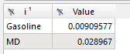
a | 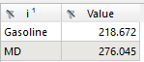
c | 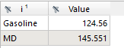
d | 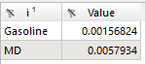
TS | 660, 213.77 ($)

The NLP model shows the economic welfare perspective of refinery operations. It highlights that both products operate at a high capacity to maximize market efficiency, boosting both producer benefit and consumer benefits. However, this part does not assume tax policy introduction or subsides.
- MCP part:
MCP part captures market equilibrium using isoelastic demand and supply functions. It takes into consideration equilibrium price and quantity that meets market balance with introducing taxes. Generally, as prices increase due to tax introduction, product cuts change, and both producer welfare and consumer welfare are reduced. In addition, complementarity conditions are considered to ensure that product price equals market price if the product is being produced. MCP part allows policy impact to show how supply and demand taxes adjust prices to maintain equilibrium. In this case, refinery will work at max capacity as we are modeling refinery and the demand is high enough, which results in no major drop in prices.
Base Case: No tax
In this case, taxes are not applicable which means $τ^{S}$= $τ^{D}=1$. Without taxes, prices are controlled by demand to balance markets. The following table shows the major findings:
Variable | Result
s1(Gasoline) | 99,952.1 (bbls/day)
s2 (MD) | 44,395 .3 (bbls/day)
Qtot | 144,347.4 (bbls/day)

Tax Scenario: Supply tax on s2 (MD)
In this case, tax is applied here only on s2 (MD). Tax applied on s2 in this example is 35%, which results notable to major drop in production from 44,395 bbls/day to 5,594 bbls/day, and the root cause of that reduction is the increment of MD production cost, shifting its supply curve upward.
Variable | Result
S1(Gasoline) | 136,042.1 (bbls/day)
S2 (MD) | 5594.4 (bbls/day)
Qtot | 141,636.5
Applying tax on s2 increases MD production cost, which leads to drop in output level and shifting more capacity toward gasoline.
This aligns with real world petroleum market where taxes have effect on production output level and reduce producer and consumer welfare.

Vision for Future Advancement/Expansion:
With unlimited time, funding, energy, and personnel, the project would upgrade into a national centralized optimization tool, which is designed to plan and optimize the refined products movement of all refineries. The objective would be to maximize the overall operational efficiency, reliability, and sensitivity of the refining system to meet the demand sustainably and in a cost-effective manner.
The advanced model would integrate multiple refineries production planning, maintenance activity scheduling, storage and distribution logistics, and business continuity strategy into a unified decision-making platform. Furthermore, this advanced tool would coordinate how crude oil and refined products move across the supply chain, taking into consideration seasonal demand patterns, prices shocks, unplanned outages in the operational side. Furthermore, it would include demand forecasting tool using real time information to respond effectively for the sake of predicting accurate demand figures. Overall, the purpose of adding those advanced monitoring and analytic features is to ensure meeting the domestic demand timely, efficiently, and according to the quality standards while minimizing cost and operation downtime.
For the long term, this model could become a centralized national refinery optimization tool that balances industry operations and environmental regulations, while improving energy security and boosting reliability to a higher level. Furthermore, a KPI could be introduced to measure how operations efficiency and customer satisfaction would improve through this unified and smart system.

Conclusion:

Appendix:

